MINUTES OF THE FINAL MEETING
8 June 2012 / Prague / Czech Republic
Participants:

CZ | Tereza Babková
AT | Martina Friedrich
BE | Johan Geentjens
CY | Rodoula Efstathiou
DE | absence due to internal deadlines
EE | Anastassia Knor
FI | Annika Sundback-Lindroos
FR | Helene Pinaud
GR | Anna Kroma
HU | Gabor Dobos
LT | Martynas Sukys, Natalija Kozlova
LV | Antra Mengele
NL | Madalena Pereira
NO | Frank Moe
PL | Anna Bielecka
SI | Sonja Mavsar
SK | Katarina Smalova

Grant agreement amendment (presentation by project coordinator)

The EMAP 2 project was selected by the EACEA for the time period of 1.10.2010 - 31.8.2012 and until now the partners managed to organize 4 very positively evaluated training seminars for 136 higher education institution (HEI) representatives formed in 48 joint programmes consortia. Still there are some activities in the project work plan, especially the evaluation of Erasmus Mundus Action 1 applications selected with a focus on the consortia trained within the project, dissemination activities and project management tasks.

As Johan (BE) was successful with a proposal for a panel session at the 24th Annual EAIE Conference, which will take place in Dublin from 11–14 September 2012, Tereza (CZ) prepared and submitted to the EACEA an amendment request proposal for the following reasons:
- need of extension of the project eligibility period until 20 September 2012 (in order to finance the participation of 3 project representatives from AT, BE and CZ at the session at the EAIE);
- change in the work plan (in order to add the EAIE session among project activities);
- budget transfers among headings of eligible costs that exceed 10% (in order to move a part of the budget from heading “Conferences and seminars” where finances will not be completely used up, to heading “Other direct costs” where finances will be used for further project promotional activities and also for the bank fees costs, that were underestimated in the initial budget).

The EAIE is the Europe´s largest international higher education conference and the panel session “How to enhance the participation in Erasmus Mundus” will promote the methodology of training seminars held within the EMAP 2 project in order to enhance the cooperation among HEIs in the framework of joint study programmes. The session will promote not only the outcomes of the EMAP 2 project, but ASEMUNDUS project too. Andries Verspeeten from the Ghent University will join the session as a speaker as he took part in the project as a best practice representative.

Johan (BE) introduced the session´s proposal submission process. The project partners were asked for a help with the session promotion (e.g. by means of their mailing lists, at their booths at EAIE etc.).

The amendment request proposal is available in the website´s restricted area.

Analysis of the EM Action 1 application results (round table)

Within the round table the project partners examined the submission rate of the applications submitted under Call 2012 by the consortia trained during EMAP 1 and 2 seminars. The results we recieved are very positive and shown in the Excel table in Annex 1. Tereza (CZ) will send the table to all partners for factual check.

The partners were asked to fill in the same table also later with the 2012 selection results and send it by email to the coordinator until 31 July 2012. There was a good idea that the results should inform about shortlisted and ineligible applications too.

There was a discussion whether or not the project should search for the reasons why some trained consortia didn´t submit their applications. The partners agreed that such information will be interesting and useful for the final report purposes and the survey will not take a lot of time. All partners also agreed with the idea that the final report should include statistics on how many representatives from underrepresented countries were trained within the project.

Overall evaluation of the four training seminars (presentation by reporting team and round table)

The project reporting team (EE, GR, CY, SK) elaborated and Anastassia (EE) presented the overall evaluation of the four training seminars. The analysis is based on the evaluation questionnaires filled in by seminar participants and focuses on the comparison of the seminars, main comments of the participants, best rated presentations, evolution of participant´s satisfaction etc. The narrative part of the analysis is available in Annex 2 and its presentation in Annex 3.

The project partners agreed that both documents are very interesting, well prepared and useful for the final report, but recommended to use a different scale for the graphs in order to present that almost all aspects of the seminars were evaluated as very good or good. As one of the often mentioned comments in the questionnaires was the timing of the training seminars, the partners discussed this issue. It is obvious that seminars not too close to the deadline would be preferred both by the participants and the project team. However the initial idea was to organize events for consortia that are almost ready to submit the application and just need to complete it. There were also practical reasons like announcement of the Call in late December, need to organize hotel tenders or wait for the pre-financing payment in the first year.

Website updates and PR issues (presentation by IT team)

Martynas (LT) prepared and presented the project website traffic and statistics of the videopresentations views, his slides are available in Annex 4. As the videos proved to be a good idea, these will be put on YouTube as well.

EM NS dissemination activities (round table)

Tereza (CZ) informed that the project website is running on a free platform and this will be sustained also beyond the project duration. Therefore also the website content should be more sustainable and user friendly. Now, the content of the website is structured according to the training seminars, but these will not be important after the project duration. There was a suggestion to reorganize the website in order to promote the project outcomes more, i.e. presentations and videos on various aspects of joint study programmes.

The project partners agreed that practical information concerning the seminars can now be removed and there could be a new item called “Project results” which will include the presentations and videos for Master and PhD programmes. The IT team will carry out the changes during summer 2012 and Tereza will prolong the website premium package which enables to have a password protection area.

A new project leaflet and promotional material (notebook with pen) were presented. The leaflet follows the idea of the new website structure and draws attention to the project outcomes at the website. The notebook refers to the website too. Leaflets and notebooks will be distributed to all project partners during summer, so that they can use it at their national events and consultations. Distribution of both items during the EAIE 2012 is planned as well. There was an idea to produce also USB keys with project outcomes.

The partners should inform Tereza how many pieces of the promotional items they need and if they are interested in the USB keys too. Please use the website restricted area until 31 July 2012 for this purpose:

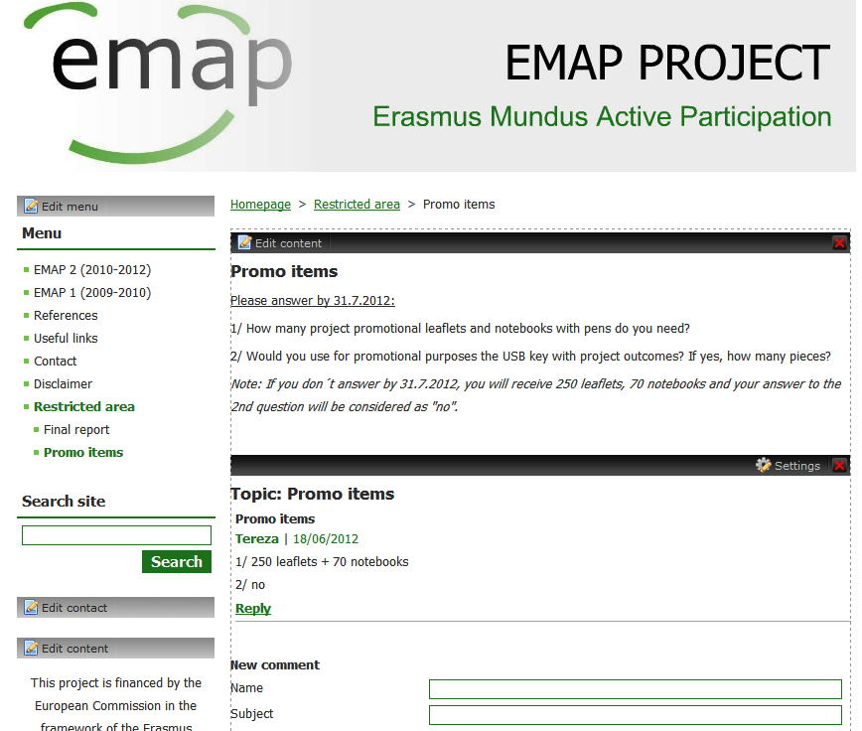
Step 1: Log in the restricted area and click on Promo items
Step 2: Read the text
Step 3: Add your answer

For the purposes of the final report, the project partners were asked to fill in the table with their dissemination activities during the whole project period and send it by email to the coordinator by 31 August 2012. The dissemination activities of partners usually involve link to project website from the institution´s webpage, mailing list, consultations, infodays or writing articles. The table can also involve planned dissemination activities (i.e. those beyong project eligibility period), as the final report should include sustainability measures as well.

Financial management and reimbursement of staff costs (presentation by project coordinator)

Tereza (CZ) presented the possible structure of budget after the grant agreement amendment and expected spending by the end of the project (see presentation in Annex 5).

Partners were asked to prepare the necessary remaining financial documentation:
- expense claim form from Prague: deadline for sending 31.7.2012
- staff conventions and timesheets: deadline for sending 31.8.2012, AT and BE until 30.9.2012
- expense claim form from EAIE: AT and BE until 30.9.2012

Annex 6 shows the overview of staff costs already declared by particular countries. Each partner must provide the time sheets and staff conventions covering the whole project duration. The distribution of time input according to the work plan should be followed, but adjustments are possible where needed. All necessary documents regarding the staff costs are available in the website restricted area under Basic documents, i.e. form for staff convention and time sheet, work plan with distribution of time input and distribution of tasks with dedicated time input.

If the amendment is approved by the EACEA, the deadline for final report submission will be 20 November 2012. Tereza plans to send the draft of the final report to all partners for comments and completion in September 2012 and if everything works well, the final report could be sent to the EACEA in October 2012.

In October 2012 each partner will receive detailed overview of costs and final amount to be reimbursed incl. request form which should be filled in and signed by responsible person. After the approval of the final report by the EACEA (i.e. 90 days after submission) this required amount will be paid to each partner.

Drafting the basic points of the final report (work in groups)

As there was no time to work on this topic during the final meeting, the project partners were asked to collaborate on the following points from the final report:
- Feedback on the implementation of the action: Describe any positive experiences, lessons learned and difficulties encountered
- Good practices: Describe any possible good practices you have developed and/or implemented in the framework of your project

Please use the website restricted area until 31 August 2012 for this purpose:

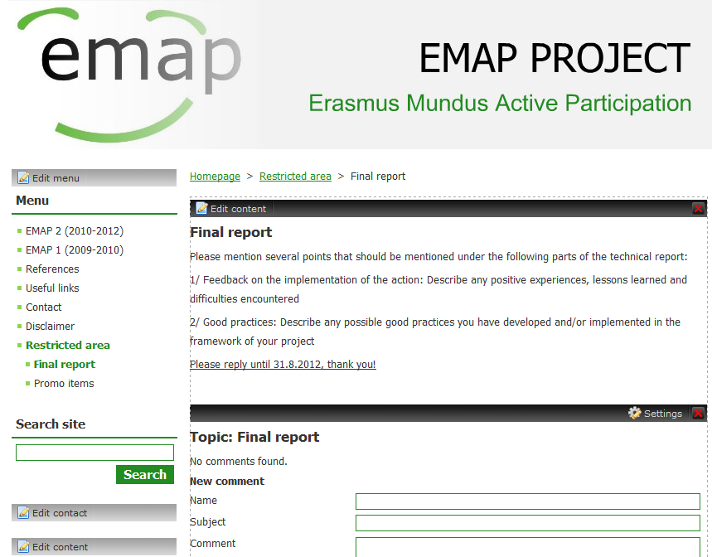
Step 1: Log in the restricted area and click on Final report
Step 2: Read the text
Step 3: Add your contribution

Evaluation of the meeting

Nr of participants: 17
Questionnaires submitted: 15

 | Excellent | Good | Fair | Poor
Information received before the event | 93% | 7%
Programme of the event | 100%
Role of speakers | 100%
Premises of the event | 100%
Organisation of the event | 100%
Timing (suitability of event day/time/length) | 80% | 20%
Catering | 100%
Overall satisfaction with the event | 93% | 7%

Participants especially liked: very good project management, work in the consortium, positive atmosphere, to know about the results and outputs, EM family soul and cooperation, presentations on application results, organization of the meeting, content of the meeting

Participants recommended to improve: more time for joint preparation of the final report, take opinion of individuals more into consideration

